ECA18 - Optoelectronics and Optical Communication
Experiment no : 09
ANALYSIS OF PHOTODETECTOR NOISE AND SNR USING MATLAB/SCILAB

OBJECTIVES
1. Analyze the key noise sources in an optical photodetector, namely shot noise, dark current noise and thermal (receiver) noise.
2. Compute the individual and total noise current variances (σ²) across a range of input optical powers.
3. Evaluate the Signal-to-Noise Ratio (SNR) and observe its scaling in the thermalnoise-limited and shot-noise-limited regimes.
4. Calculate the Minimum Detectable Optical Power (Pmin) at SNR = 1 (0 dB).
5. Simulate and visualize photodetector noise and SNR curves using MATLAB.

SOFTWARE REQUIRED
• MATLAB (or GNU Octave / Scilab)

SAMPLE MATLAB PROGRAM
% Photodetector Noise and SNR Analysis
clc; clear;
close all;
%% 1. Constants and input parameters
q = 1.602e-19; kB = 1.381e-23; h = 6.626e-34; c = 2.998e8;
lambda = 1550e-9; % wavelength (m)
eta = 0.85; % quantum efficiency
Id = 5e-9; % dark current (A)
T = 300; % temperature (K)
RL = 50; % load resistance (ohm)
Fn = 2; % noise figure (3 dB = 2 linear)
B = 1e9; % bandwidth (Hz)
Pdbm = -60:0.1:0; % input power sweep (dBm)
P = 10.^((Pdbm-30)/10); % input power (W)
%% 2. Responsivity and signal current
R = eta*q*lambda/(h*c);
Ip = R*P;

56

%% 3. Noise variances and SNR
var_shot = 2*q*Ip*B;
var_dark = 2*q*Id*B;
var_th = 4*kB*T*B*Fn/RL;
var_tot = var_shot + var_dark + var_th;
SNR_dB = 10*log10(Ip.^2 ./ var_tot);
%% 4. Minimum detectable power (SNR = 1)
a = R^2; b = -2*q*B*R; cc = -(var_dark + var_th);
Pmin = (-b + sqrt(b^2 - 4*a*cc))/(2*a);
PmindBm = 10*log10(Pmin) + 30;
%% 5. Display results
[~,k] = min(abs(Pdbm+30)); % index of -30 dBm
fprintf('Responsivity R = %.4f A/W\n', R);
fprintf('Thermal variance = %.3e A^2\n', var_th);
fprintf('Dark variance = %.3e A^2\n', var_dark);
fprintf('Shot variance(-30) = %.3e A^2\n', var_shot(k));
fprintf('SNR at -30 dBm = %.2f dB\n', SNR_dB(k));
fprintf('Pmin (SNR = 1) = %.2f dBm (%.1f nW)\n', PmindBm, Pmin*1e9);
%% 6. Plots
subplot(2,1,1);
loglog(P, var_th*ones(size(P)), P, var_dark*ones(size(P)), P, var_shot, P, var_tot);
grid on; xlabel('P_{in} (W)'); ylabel('Noise variance (A^2)');
legend('Thermal','Dark','Shot','Total','Location','best');
subplot(2,1,2);
plot(Pdbm, SNR_dB); hold on; plot([-60 0],[0 0],'r--'); plot([PmindBm PmindBm],[-60
70],'k:');
grid on; xlabel('P_{in} (dBm)'); ylabel('SNR (dB)');

OUTPUT GRAPH
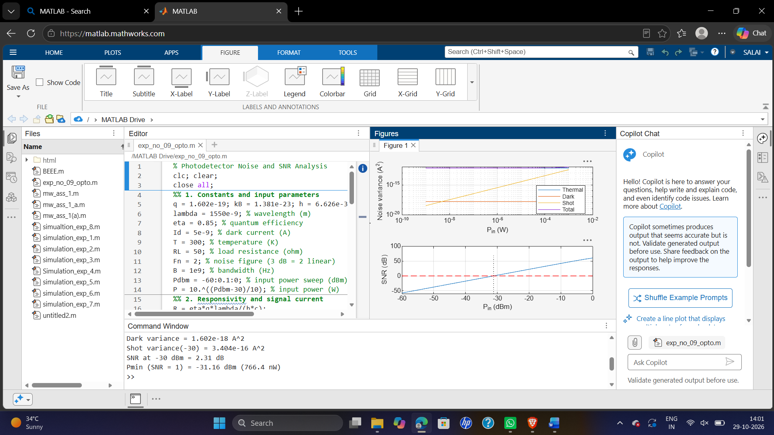

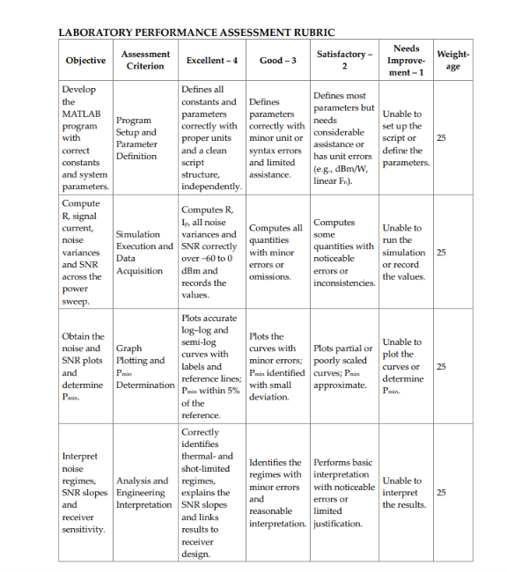

RESULT
The photodetector noise and Signal-to-Noise Ratio (SNR) were analyzed using MATLAB/Scilab. It was observed that increasing noise reduces the SNR, while a stronger signal improves the SNR and the quality of detection.

REFLECTION
This experiment helped me understand different types of photodetector noise and their effects on signal quality. I learned how to simulate noise, calculate SNR, and analyze the results using MATLAB/Scilab.

